Creating an internal email treatment designed in an external tool
Steps :
- Download exercise articraft
- extractit into local machine
  - 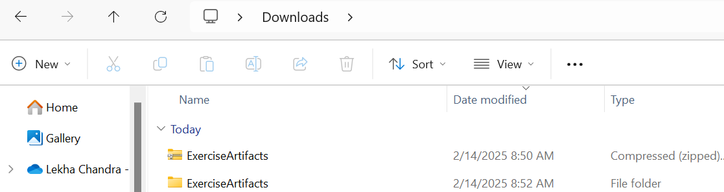
- Update addressing from Dear Sir/Madam, to Dear <pega:reference name=".Customer.FullName"></pega:reference>
- Create internal treatment for rewards card
  - 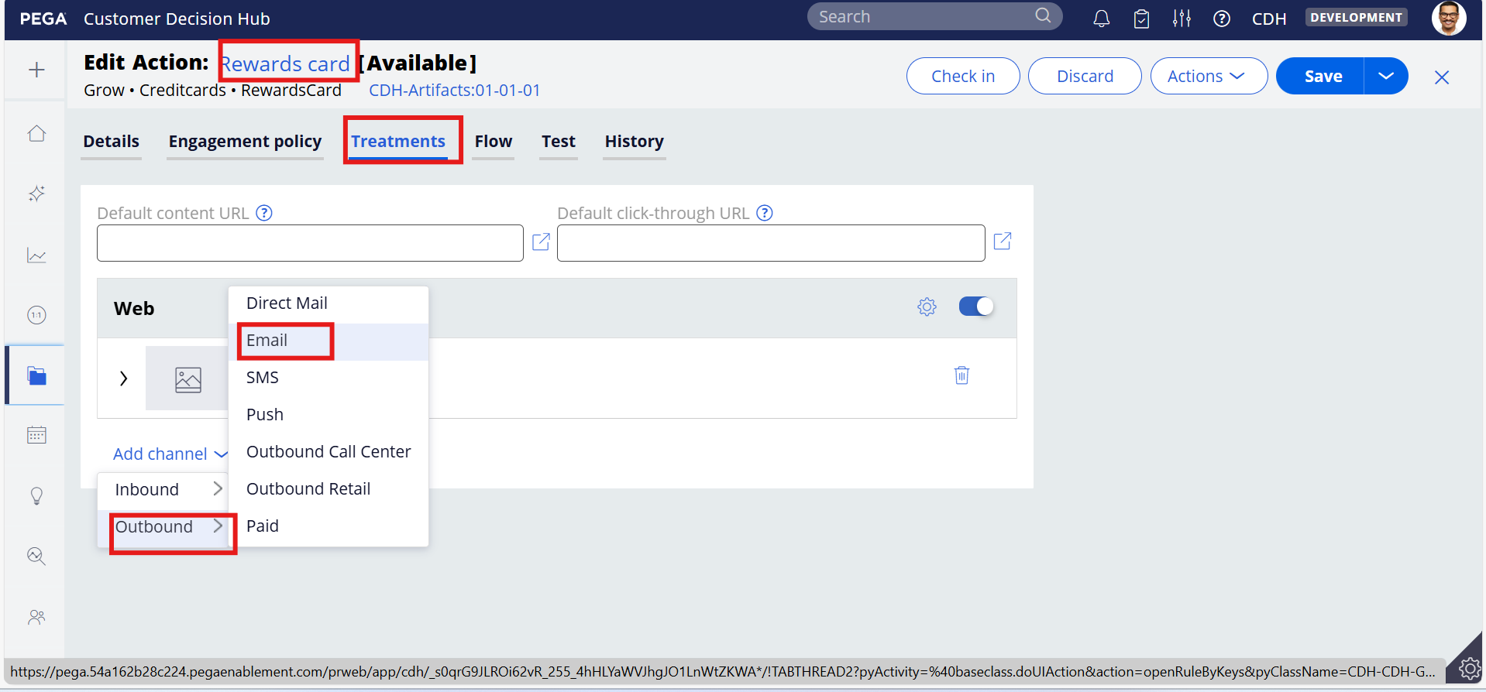
  - 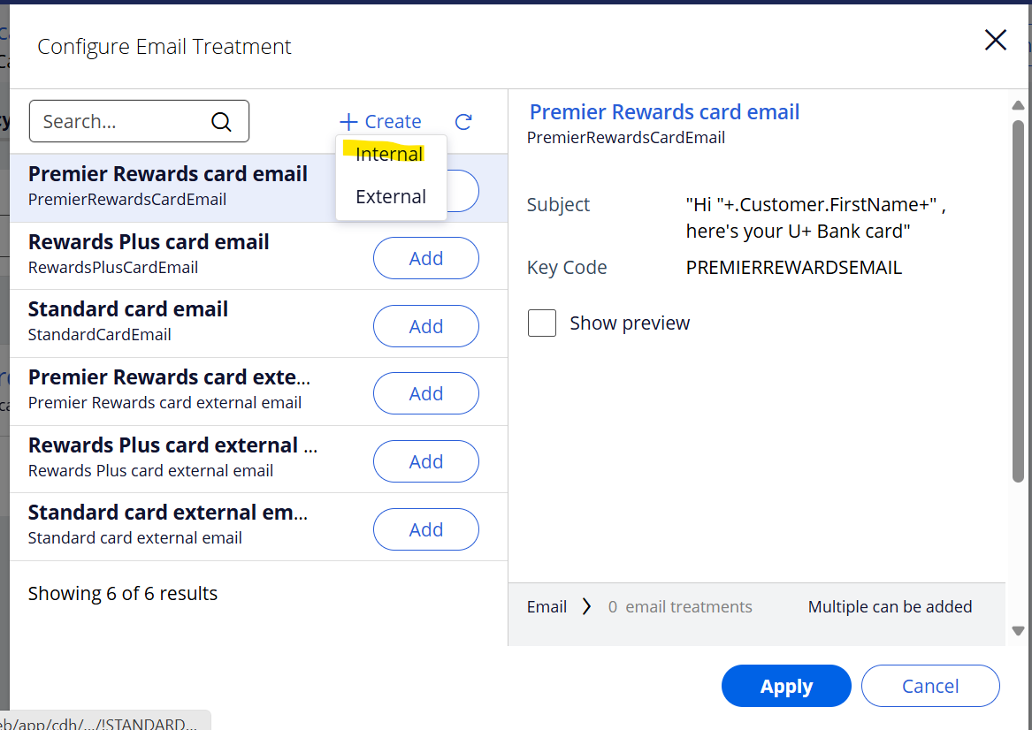
  - 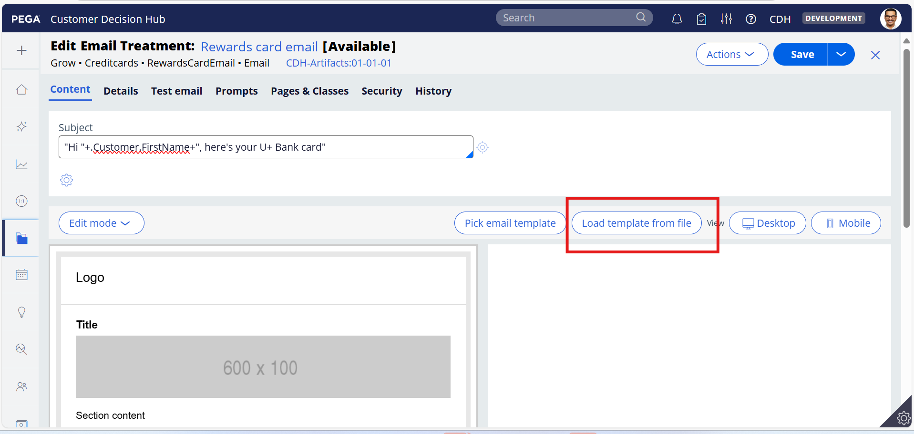
  - Upload edited html file(RewardsCard.html)
    - 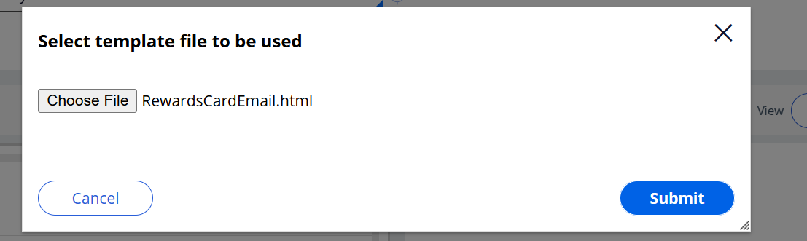
  - Save
- Go back to rewards card treatment tab and add newly created internal treatment
  - 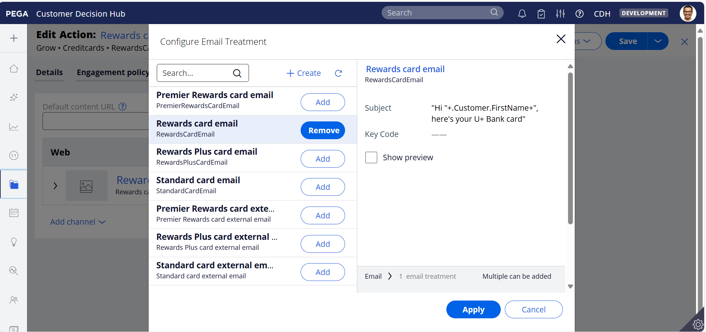
  - Save it
  - 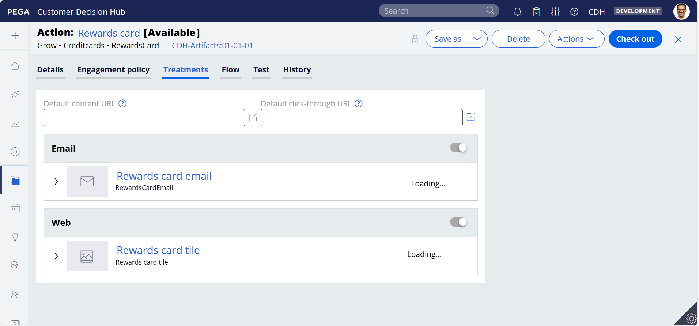
- Testing
  - Open Test email tab under email treatment (Rewards card email)
  - 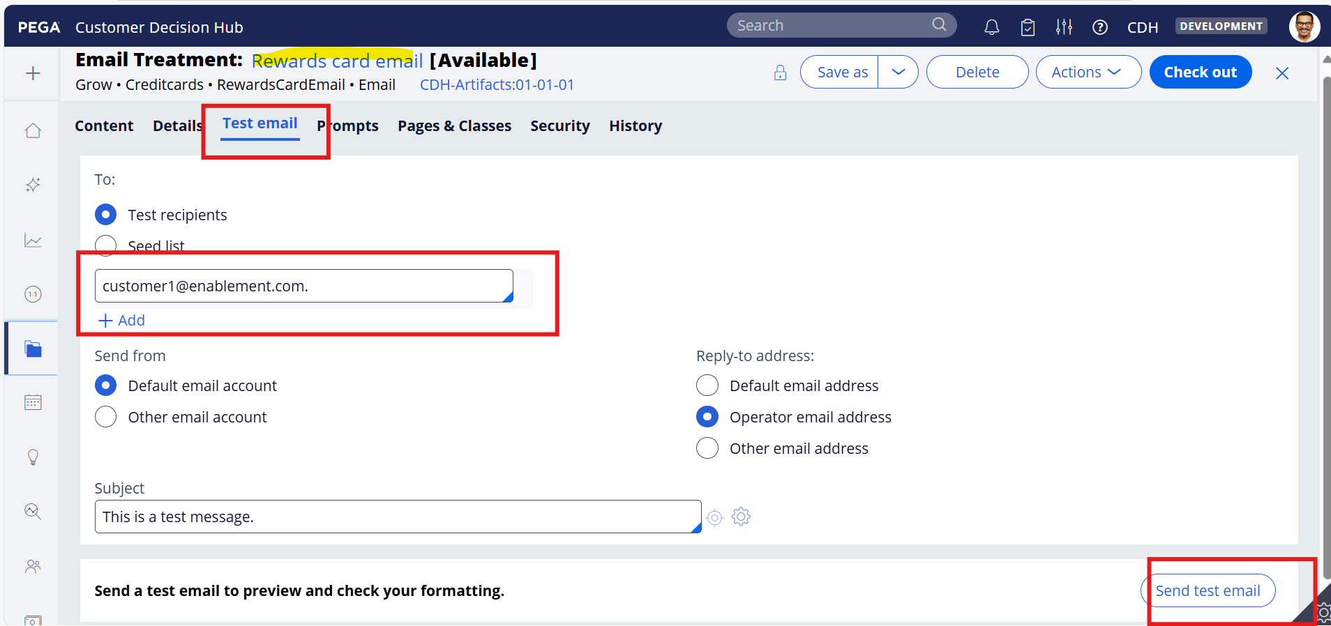
  - 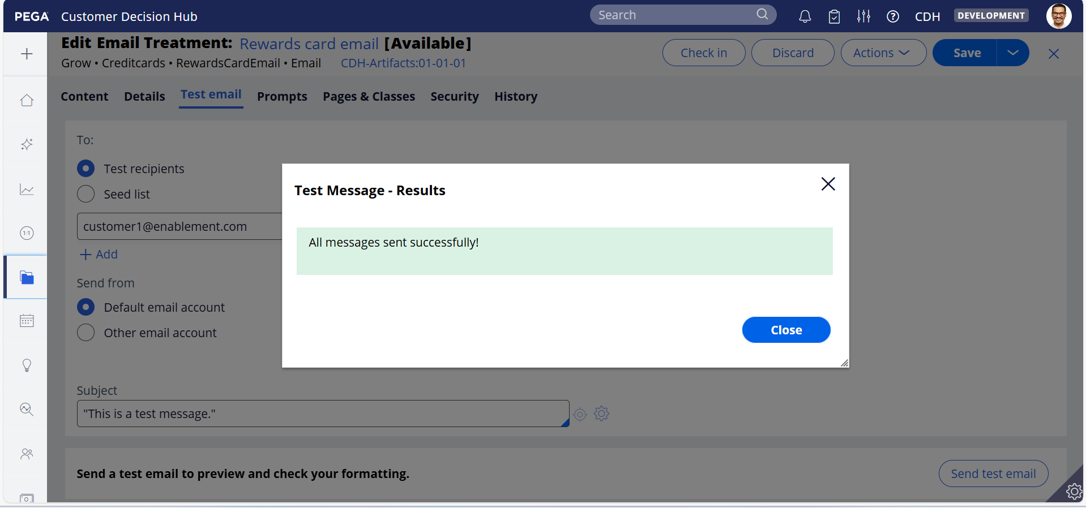
  - 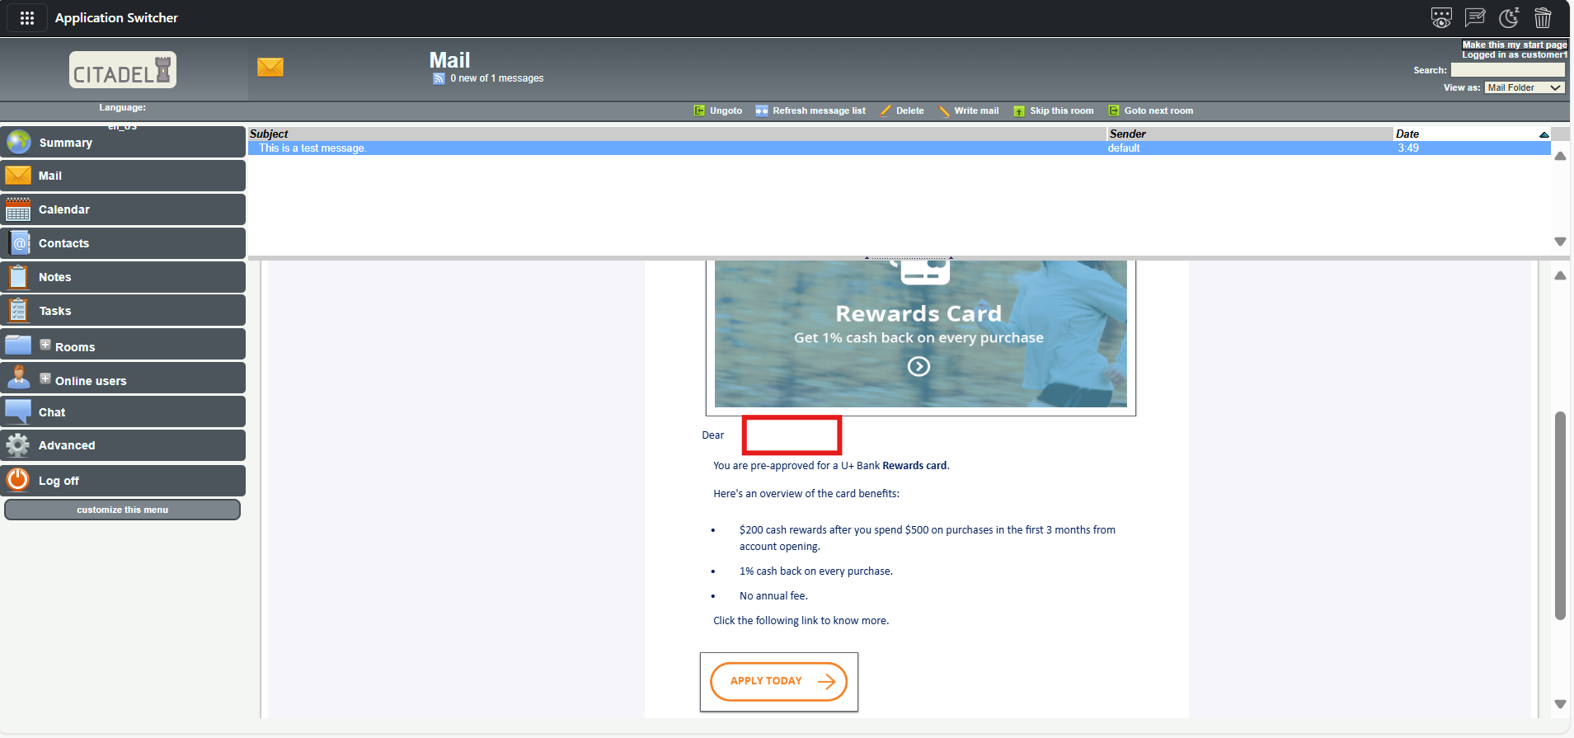
  - Here we directly added email id, so name is not present
  - Goto email treatment test mail tab again select seed list and add StephenGold
  - 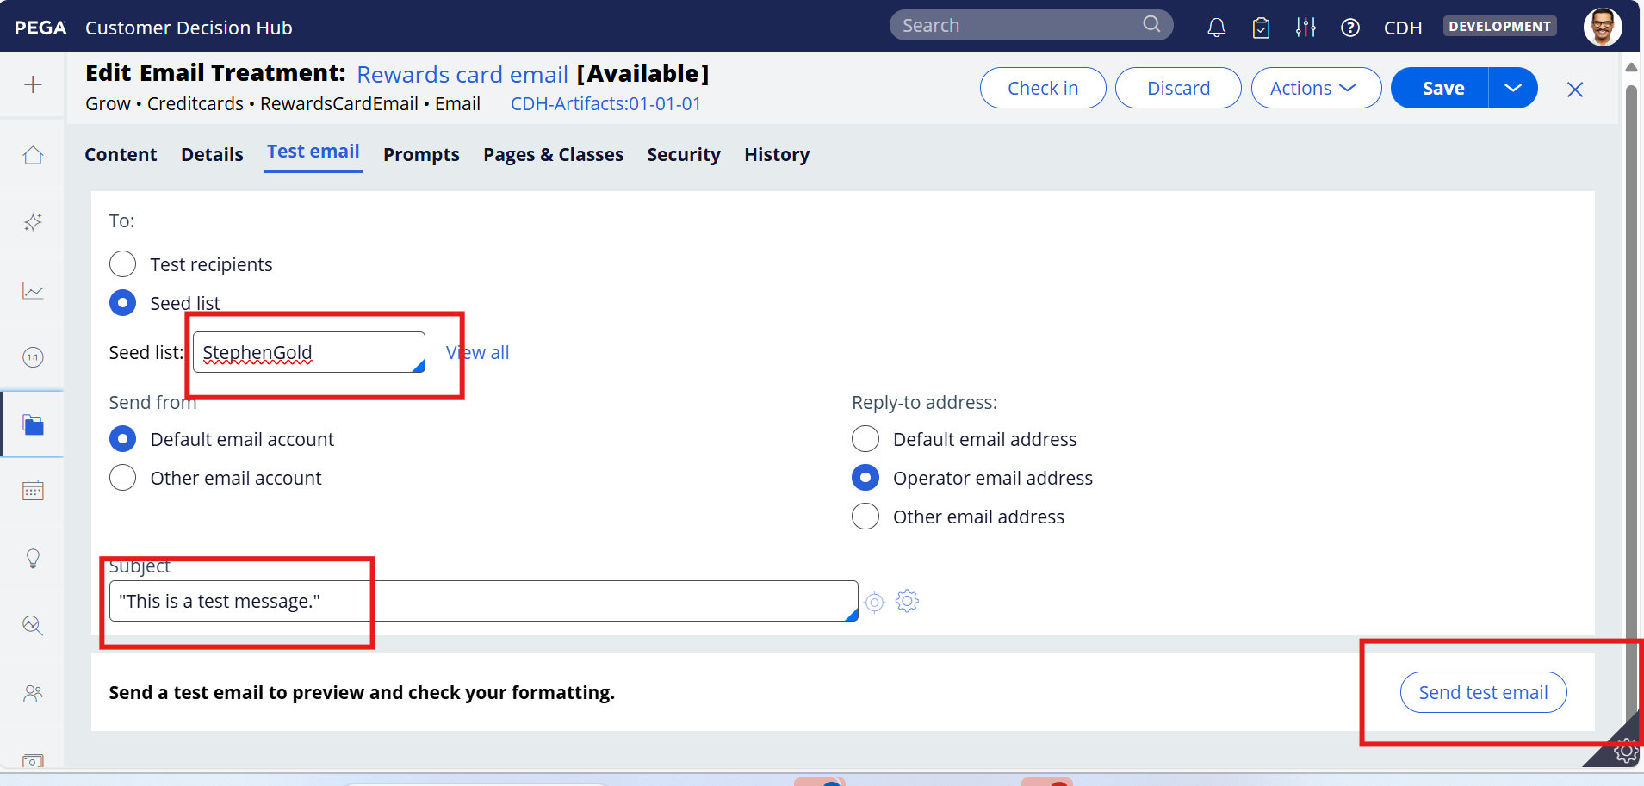
  - 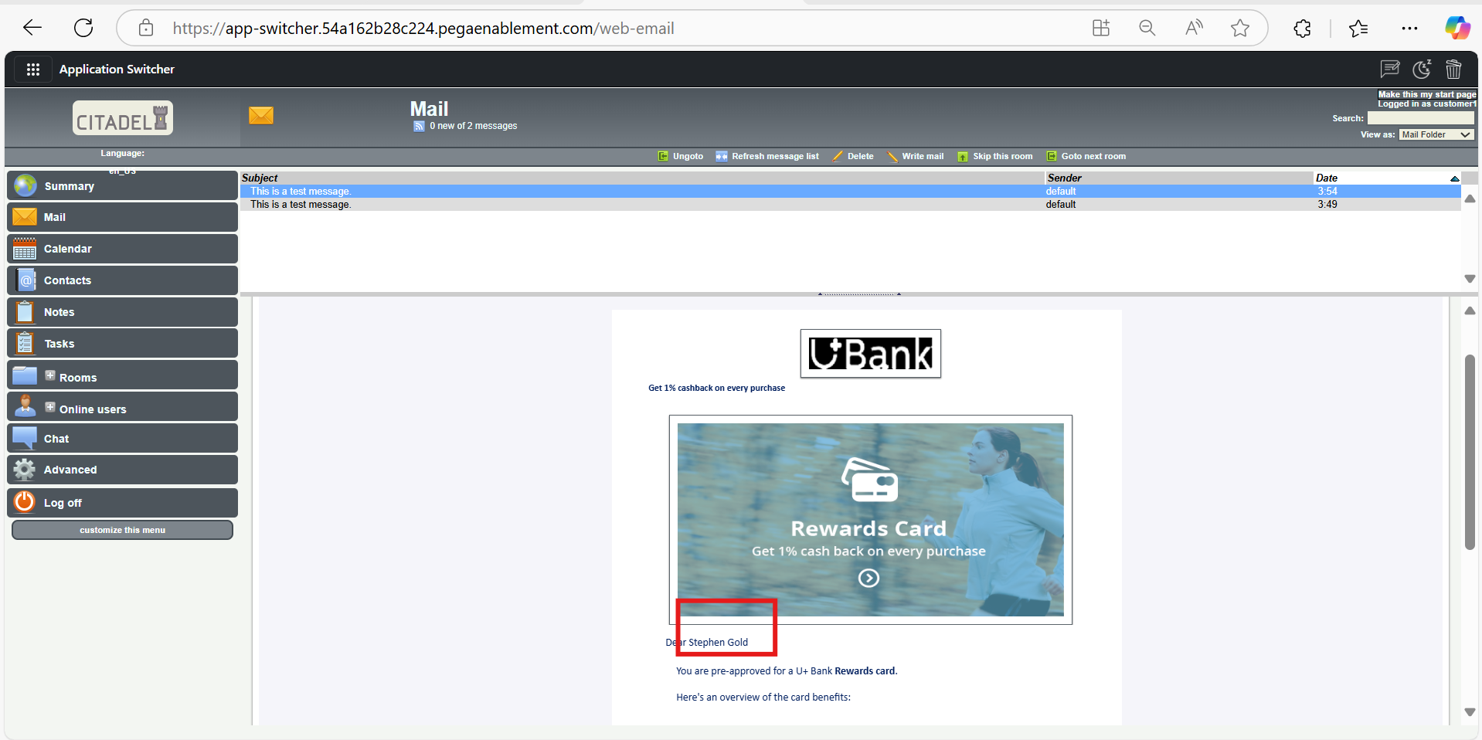
  - done

